HANU Training Management System

Use-Case-Realization Specification: Dormitory Registration (Student)

Version 1.0

*[Note: The following template is provided for use with the Rational Unified Process. Text enclosed in square brackets and displayed in blue italics (style=InfoBlue) is included to provide guidance to the author and should be deleted before publishing the document. A paragraph entered following this style will automatically be set to normal (style=Body Text).]*

*[To customize automatic fields in Microsoft Word (which display a gray background when selected), select File>Properties and replace the Title, Subject and Company fields with the appropriate information for this document. After closing the dialog, automatic fields may be updated throughout the document by selecting Edit>Select All (or Ctrl-A) and pressing F9, or simply click on the field and press F9. This must be done separately for Headers and Footers. Alt-F9 will toggle between displaying the field names and the field contents. See Word help for more information on working with fields.]*

Revision History

| **Date** | **Version** | **Description** | **Author** |
| --- | --- | --- | --- |
| 05/12/2021 | 1.0 | Draft | Nguyễn Ngọc Huyền |
| 08/12/2021 | 1.0 | Final | Nguyễn Ngọc Huyền |
|  |  |  |  |
|  |  |  |  |

Table of Contents

1. Introduction 4

1.1 Purpose 4

1.2 Scope 4

1.3 Definitions, Acronyms, and Abbreviations 4

1.4 References 4

1.5 Overview 4

2. Flow of Events—Design 5

3. Derived Requirements 6

Use-Case-Realization Specification:

Dormitory Registration

# Introduction

## Purpose

This document describes how the Dormitory Registration Use-Case is realized within the design model, in terms of collaborating objects.

## Scope

This document is strictly associated with the Dormitory Registration Use-Case.

## Definitions, Acronyms, and Abbreviations

* Student – a person who studies in a university.

## References

[1] **Dormitory Registration (Student) – Use Case Specification**, Nguyen Ngoc Huyen, December 5th 2021, HANU Training Management System.

## Overview

In the following section, Use-Case Realization Specification of the Dormitory Registration Use-Case of the HANU Training Management System is provided in detail. The first section is a textual description of the Use-Case specification. The following section contains diagrams (sequence and class diagrams) describing how the use case is realized in terms of collaborating objects.

# Flow of Events—Design

## sequence diagram

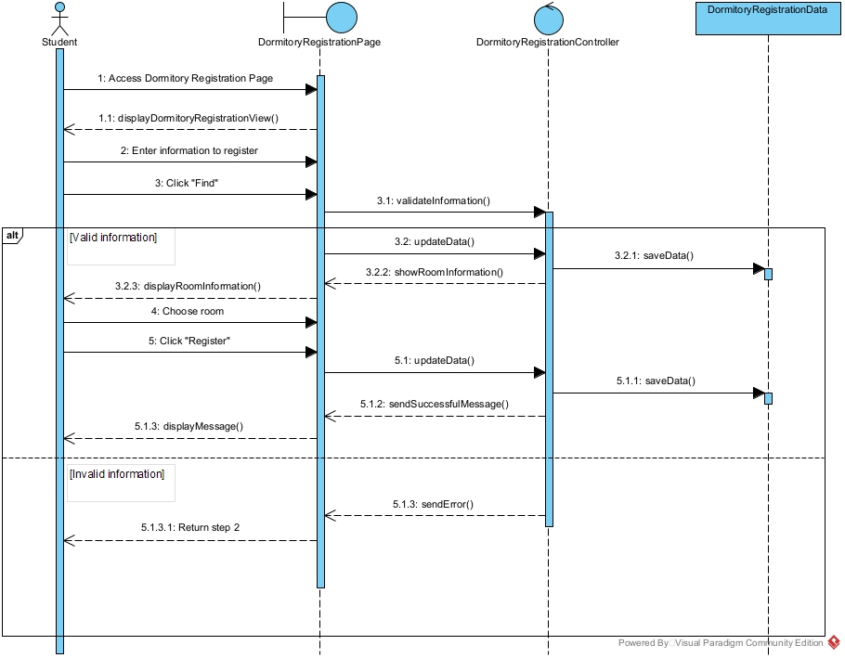

## class diagram

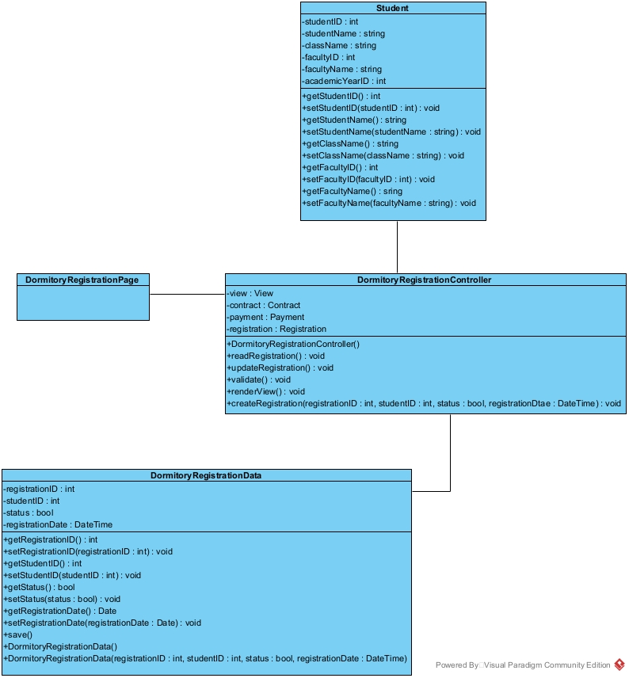

# Derived Requirements

After the successful update, the system should return the user to the dormitory registration view, where students can review all the information available.